Rafik’s Kitchen Expenses

Analysis-2022

**Over Viewing the data:**

SELECT * FROM [Expenses 2022]

**KPI’s Analysis:**

1. **Total Expenses**

SELECTFORMAT(SUM(FINAL_AMOUNT),'C','EN-IN')AS TOTAL_EXPENSES FROM [Expenses 2022]

**OUTPUT:**



1. **Monthly Expenses:**

SELECT DATENAME(MONTH,DATE) AS MONTH, FORMAT(SUM(FINAL_AMOUNT),'C','EN-IN') AS EXPENSES_AMOUNT

FROM [Expenses 2022]

GROUP BY DATEPART(MONTH, DATE), DATENAME(MONTH,DATE)

ORDER BY DATEPART(MONTH,DATE)

**OUTPUT:**

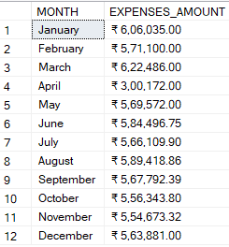

1. **Categorical Expenses:**

SELECT EXPENSES AS CATEGORY,

FORMAT(SUM(FINAL_AMOUNT),'C','EN-IN') AS AMOUNT FROM [Expenses 2022]

WHERE FINAL_AMOUNT<>0

GROUP BY EXPENSES

ORDER BY SUM(FINAL_AMOUNT) DESC

**Output:**

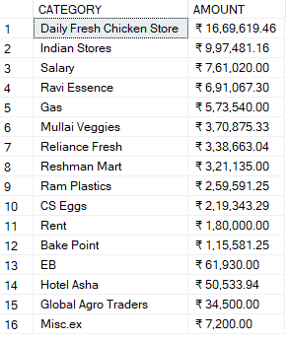

1. **Total Credit Amount & Percentage of Credit:**

SELECT FORMAT(SUM(CARRY_FORWARD), 'C','EN-IN') AS TOTAL_CREDIT_AMOUNT,

FORMAT(SUM(CARRY_FORWARD)*100/(SELECT SUM(FINAL_AMOUNT) FROM [Expenses 2022]),'N2')+'%'

AS PERCENTAGE_OF_CREDIT_PURCHASE FROM [Expenses 2022]

**Output:**



1. **Credit Amount & Percentage of Credit by Category:**

SELECT EXPENSES AS CATEGORY,

FORMAT(SUM(CARRY_FORWARD), 'C','EN-IN') AS CREDIT_AMOUNT,

FORMAT(SUM(CARRY_FORWARD)*100/(SELECT SUM(FINAL_AMOUNT) FROM [Expenses 2022]),'N2')+'%'

AS PERCENTAGE_OF_CREDIT_PURCHASE FROM [Expenses 2022]

WHERE CARRY_FORWARD<>0 GROUP BY EXPENSES ORDER BY SUM(CARRY_FORWARD) DESC

**Output:**

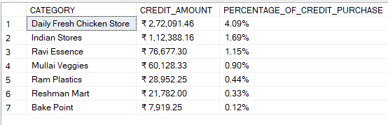

1. **Credit Amount & Percentage of Credit by category:**

SELECT DATENAME(MONTH,DATE) AS MONTH,

FORMAT(SUM(CARRY_FORWARD), 'C','EN-IN') AS CREDIT_AMOUNT,

FORMAT(SUM(CARRY_FORWARD)*100/(SELECT SUM(FINAL_AMOUNT) FROM [Expenses 2022]),'N2')+'%'

AS PERCENTAGE_OF_CREDIT_PURCHASE FROM [Expenses 2022]

WHERE CARRY_FORWARD<>0 GROUP BY DATEPART(MONTH, DATE), DATENAME(MONTH,DATE)

ORDER BY DATEPART(MONTH,DATE)

**Output:**

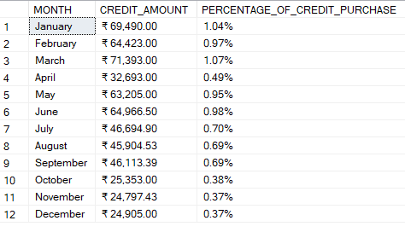

1. **Yearly Expenses For Salary, Rent and Percentage of Selected Expenses:**

SELECT EXPENSES AS CATEGORY,

FORMAT(SUM(FINAL_AMOUNT),'C','EN-IN') AS AMOUNT,

FORMAT(SUM(FINAL_AMOUNT)*100/(SELECT SUM(FINAL_AMOUNT) FROM [EXPENSES 2022]),'N2')+'%'

AS PERCENTAGE_OF_EXPENSES FROM [EXPENSES 2022]

WHERE EXPENSES IN ('SALARY','RENT','EB') GROUP BY EXPENSES

ORDER BY SUM(FINAL_AMOUNT) DESC

**Output:**

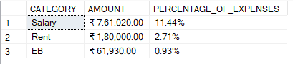

1. **Monthly Expenses For Salary, Rent and Percentage of Selected Expenses:**

SELECT DATENAME(MONTH,DATE) AS MONTH,

FORMAT(SUM(FINAL_AMOUNT),'C','EN-IN') AS AMOUNT,

FORMAT(SUM(FINAL_AMOUNT)*100/(SELECT SUM(FINAL_AMOUNT) FROM [EXPENSES 2022]),'N2')+'%'

AS PERCENTAGE_OF_EXPENSES FROM [EXPENSES 2022]

WHERE EXPENSES IN ('SALARY','RENT','EB') GROUP BY DATEPART(MONTH, DATE), DATENAME(MONTH,DATE)

ORDER BY DATEPART(MONTH,DATE)

**Output:**

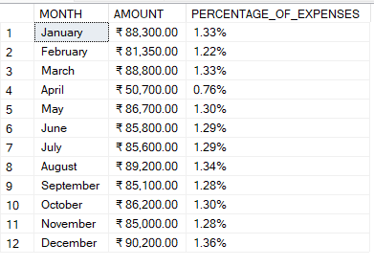

1. **Total Discount Amount by Category:**

SELECT EXPENSES AS CATEGORY,

FORMAT(SUM(DISCOUNT), 'C','EN-IN') AS DISCOUNT_AMOUNT FROM [Expenses 2022]

WHERE DISCOUNT<>0 GROUP BY EXPENSES

ORDER BY SUM(DISCOUNT) DESC

**Output:**

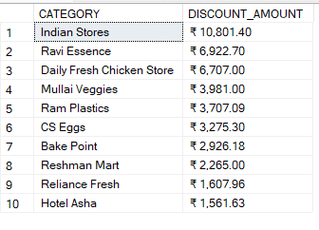

1. **Percentage of Discount by Category:**

SELECT EXPENSES AS CATEGORY,

FORMAT(SUM(DISCOUNT)*100/(SELECT SUM(DISCOUNT) FROM [EXPENSES 2022]),'N2')+'%'

AS PERCENTAGE_OF_DISCOUNT FROM [EXPENSES 2022]

WHERE DISCOUNT<>0 GROUP BY EXPENSES

ORDER BY SUM(DISCOUNT) DESC

**Output:**

